**Develops**

**CLOUD:-**

* The cloud allow users to access data, applications and computing resources from anywhere in the world.
* Without internet you can’t access them is know as a cloud.

**CLOUD COMPUTING:-**

Cloud computing refers to the delivery of computing services, including servers storage, database, networking, software and analytics, over the internet.

In cloud computing we have 2 types :

1. Deployment Model
2. Services Model

**Deployment Model : -**

Cloud deployment model defines the who can access the cloud resources and how a cloud is located is know as a deployment model.

In deployment model we have 4 types:-

1. Public Cloud
2. Private Cloud
3. Hybrid Cloud
4. Community Cloud.

**Public Cloud:-**

A public cloud is a cloud computing model in which services are delivered over the public internet and share across organizations. public cloud allows every one can access the cloud with the help of internet connection

Advantages:-

* Low cost
* No maintance
* Reliable.

**Private cloud:-**

In private cloud means in private cloud resources allows only with in the Organization.

operate only with in a particular organization. It “**pay per use”**

**Advantages:-**

* High security
* More control.

**Hybrid Cloud:-**

It is a combination of public and private.

**Advantage:-**

* flexible and secure
* cost effective.

**Community cloud:-**

It access the group of organization is know as a community cloud .

**Services model:-**

It has a four models :

1. Software as a service (SAAS)
2. Platform of a service(PAAS)
3. Infrastructure as a service (IAAS)
4. Function as a service(FAAS)

**Software as a service (SAAS):-**

Saas it is pre-existed application are accessible through internet connection.

1.google app. engine

2.salesforce.com

**Platform of a service(PAAS)**

It develop new IT system application with help of cloud platform. cloud offers the rent the platform to developers/organization.

**Infrastructure as a service (IAAS)**

Virtualized infrastructure can rent and develop a new application.

**Function as a service(FAAS)**

It breaks cloud applications down into even smaller components that only run when they are needed.

**AWS (AMAZON WEB SERVICE)**

It is best cloud provider. It is first among all clouds. It offer multiple services on different domains It is the combination SAAS, IAAS, PAAS.

**Advantages:**

cost benefits:-

* pay as you go model
* purchasing options
* Global availability
* automation options.

**Why use AWS:**

* Security and durability
* flexibility,
* ease of use
* scalability
* cost saving.

Aws global infrastructure is divided into geographical region .the geographical regions are then divided into separate availability zones.

**DevOps:**

It is a combinations of development and operations.It is process of delivery the product /project by ensuring automation in place, ensuring the quality with continuous monitoring and testing.

**Why do DevOps :-**

To deliver the software or project etc….on time.

DevOps uses the CI/CD(Continuous Integration (CI)/ Continuous Delivery (CD)

**SDLC (SOFTWARE DEVELOPMENT LIFE CYCLE)**

It is process used by software industry.

**Water fall Model:-**

* Water fall is also know as a linear sequential model.
* It can contain different phases are present.
* The first phase output become a input of the second phase .

Waterfall model can contain 6 phase:-

**1.Software Requirements& Gathering:-**

Here business analyst will collect the requirements from the client. After gathering the requirements will prepare the document **Business Requirements** **Specifications**(BRS). After sending requirements to forward to analysis**.**

**2.Analysis & Planning:-**

The documents are Studie and understanding the document what is the requirements will do or not. After complete the understanding they will prepare the document is **Software Requirement Specification**(SRS). And also planning the team ,schedules, strategy etc..

**3.Design:-**

There will prepare the blue print for the application. Tasks to the teams:-high level, low level.

**4.coding:-**

Starting the coding to the client requirement and there complete the coding there will send testers.

**5.Testing:-**

The testers follows the verification and validation process and there verify the requirement document functional and non-functionality (functional means click button actions and linking actions etc.. and non functionality means graphical visible etc.)

**6.Deployment:-**

Release the software application to client there check the application for there requirements or not.

**7.Maintance:-**

Give the updates for the client side requirements.

**Advantages :-**

1. Very easy to developed the project.
2. Time doesn’t taken use only small program
3. All phases are clear and clarity.

**Disadvantages:-**

1. This model only used short/small projects not a longer projects.
2. Reverse process doesn’t allow.

**Agile model:-**

* Agile model is a type of iterative and incremental process model.
* Agile focus on process adaptability and customer scarification by fast delivery of working software product.
* Agile methods break product into smaller iterations avoid long term planning.
* The ability to respond to the changes from requirements, technology & people

Advantage:-

* Requirement changes are allowed at any stage of development.
* Release will be very fast.
* Customers no need of waiting for longer time.
* Good communication will be there between all the teams.
* It is very easy to adopt.

Disadvantages:-

* Less focus on design &documentation.

**Testing :-**

It is one of the process in software development and here testers are involve and they will checking whether the developed software is properly developed or not.

It undergo the manual testing.

It has 3 types:

1. White box testing :Developers will test each & every line of code.
2. Black testing:- Black box testing is that kind of software testing you can do when you do not have the source code, just the executable code in hand .
3. Grey box testing:-Combination of both White box testing and Black box Testing.

In Black box testing. It has 2 types:

* Functional Testing : Checking the all user requirements is know as functional testing.
* Non-Functional Testing: Checking the all user expectation are known as non-functional testing.

In functional it has 3 types:-

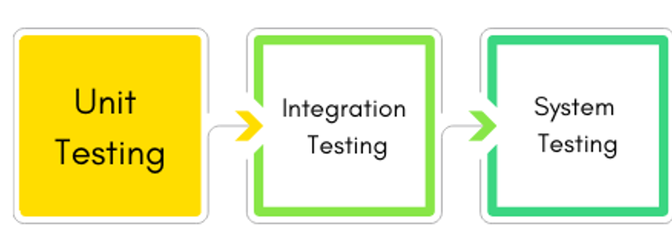

**Unit Testing:-**

* It is first level testing done by developers.
* It is a white box testing type and it is also known as module level testing.
* The developers are checking the code after development by using white box testing technique.

**Integration Testing:**

* It is also done by developers. It is a white box testing type.
* Here developers are integrated with one module to another module and checking the data between 2 moules.

Integration done in 2 ways :

* Incremental :- Top-Down, Bottom-top
* Non-incremental :-Big-Bang

**System Testing:-**

It is done by testing . It is a black box testing type. Here testers are validation the functional and non functional.

**Key words:-**

Bugs:-Developer will develop the code operations team(testing:-finds any error)

Error:-Mistakes in coding done by the developer.

Defect:-The error which is accepted by the developer.

Failure:-Total wrong.

**Tools Required:-**

Planning/Coding/SCM:-Git, Jira

Building the Code:-Maven, Gradle, Apache Ant

Testing:-Selenium Testing with python

Integration:-Jenkins(CI/CD)

Deployment:-Dockers, Kubernetes

Operations:-Ansible(Managing tool)

Monitoring:- Terraform